Nagios Log Server:

These are my notes from 3/22/2024: starting the project again. So far, I have had 3 attempts and the 1st attempt was the most successful one. This was with the original recording and doing the automatic installation. I will start with the last recording that was done by Prof Clovis, strictly for the minimal requirement and then switch back to the original recording as that seemed to work the easiest. Below was where I got stuck, I am not sure if it is strictly the location within the config file or something else affecting the elasticsearch command. It says invalid environment?

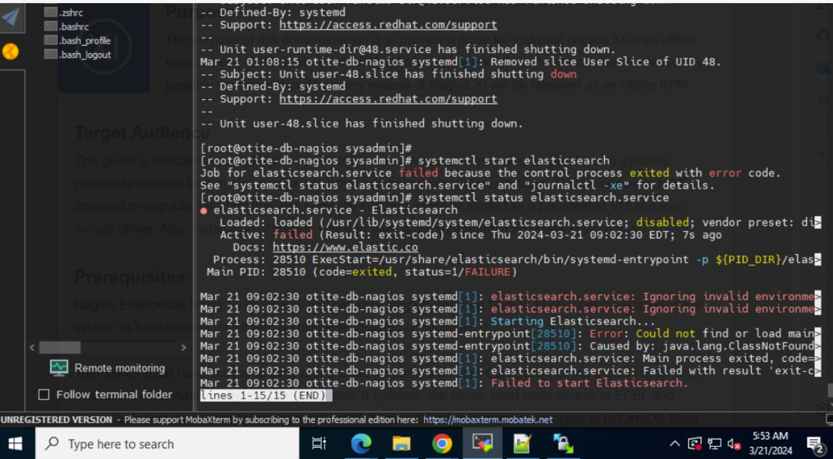

Here is the tail of the var/log/message:

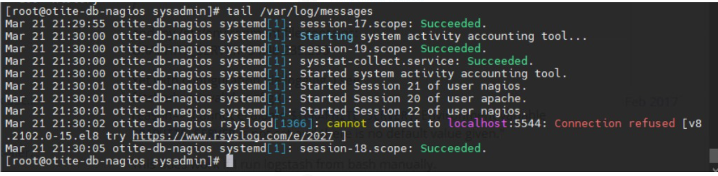

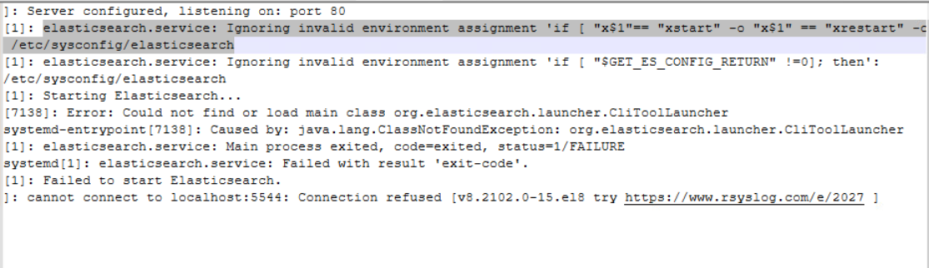

I cd into the location /etc/sysconfig/elasticsearch and made the change below:

New start for TechP3:

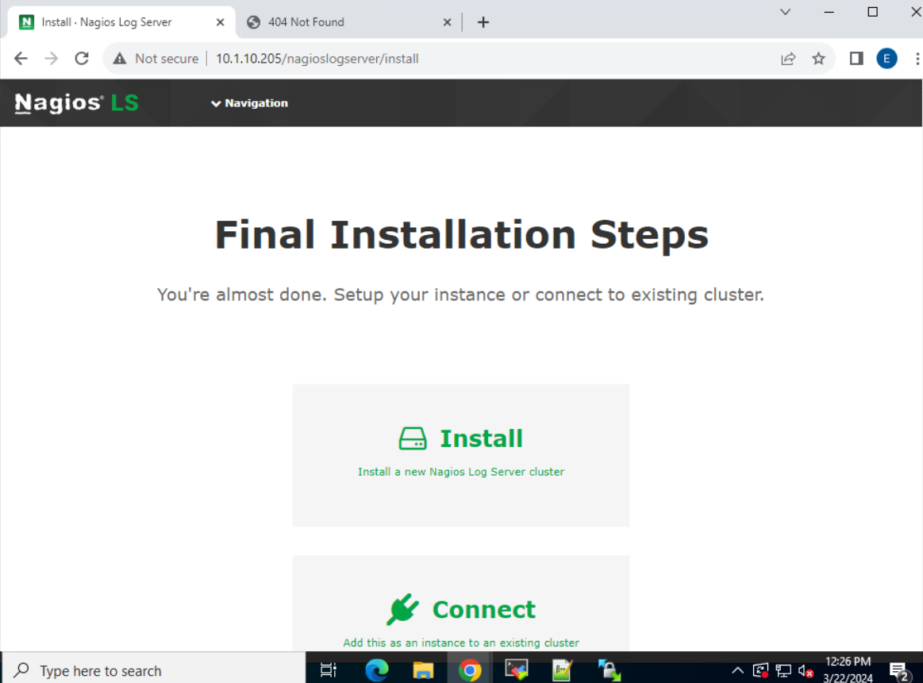

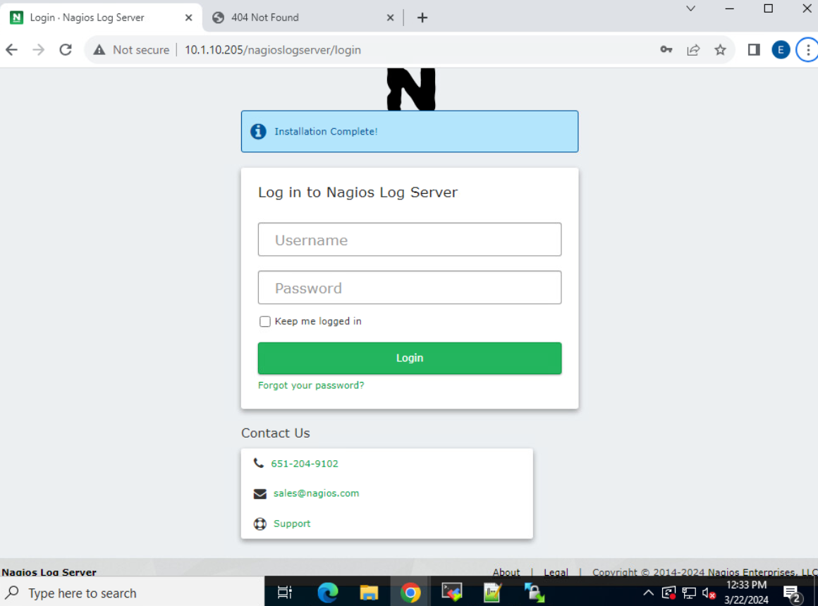

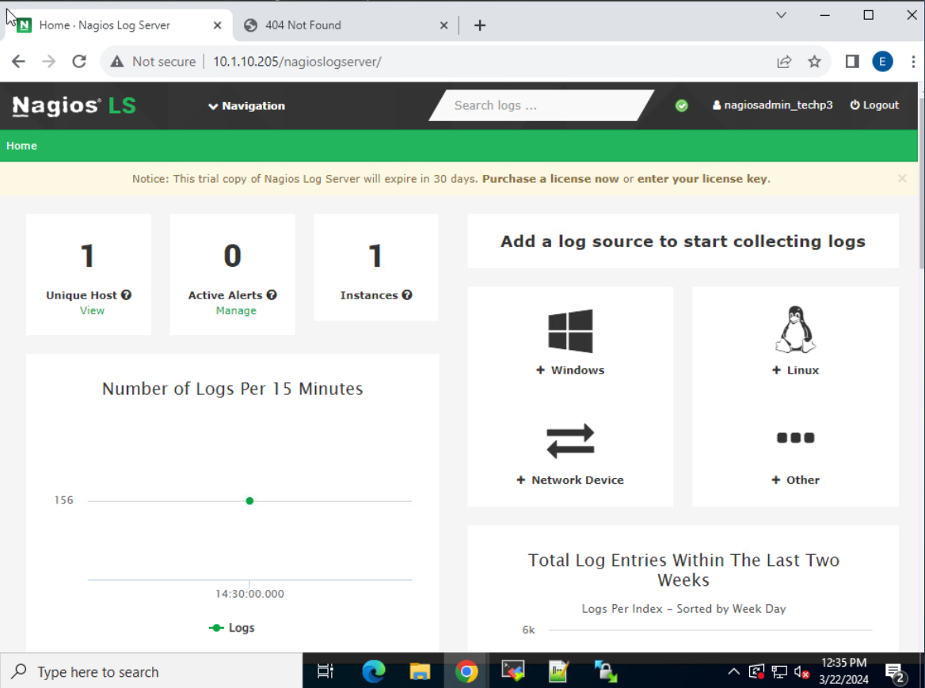

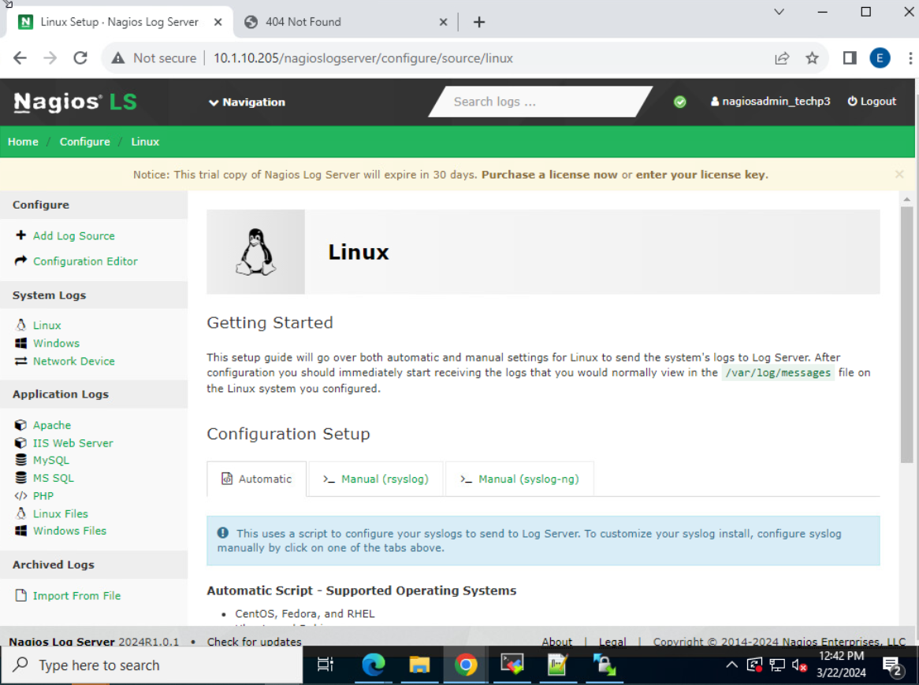

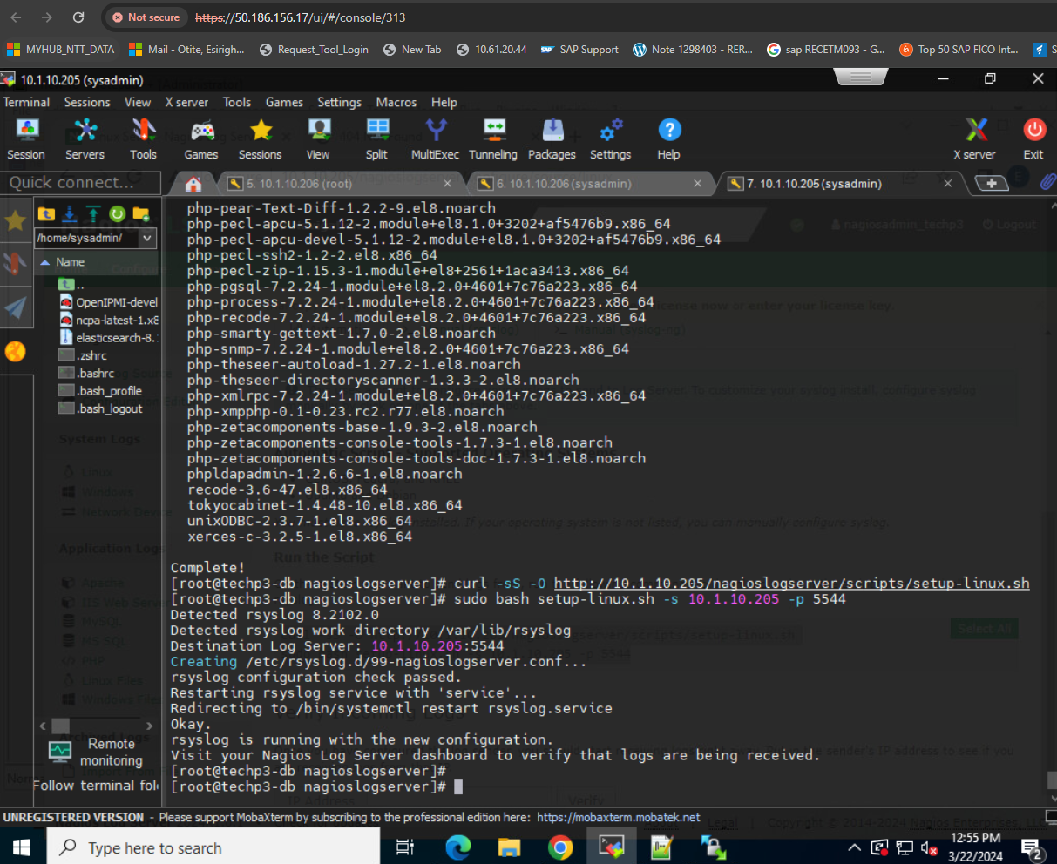

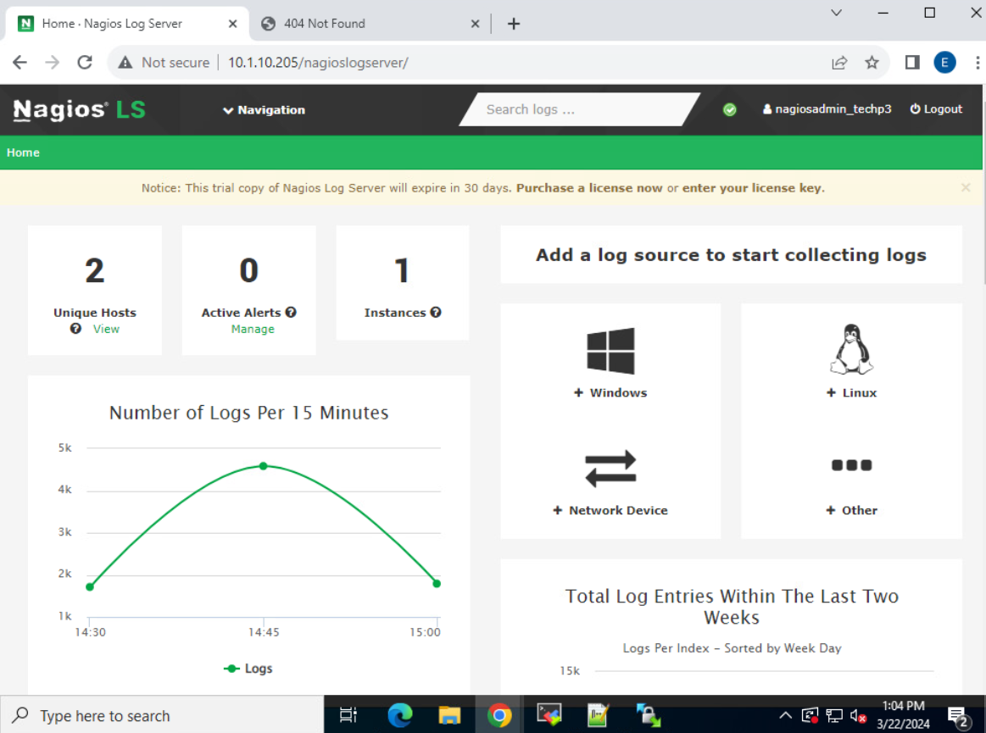

--------Worked using the auto approach-------

1. Cd /tmp (Because this is where we keep our temporary file for easy installations)
2. 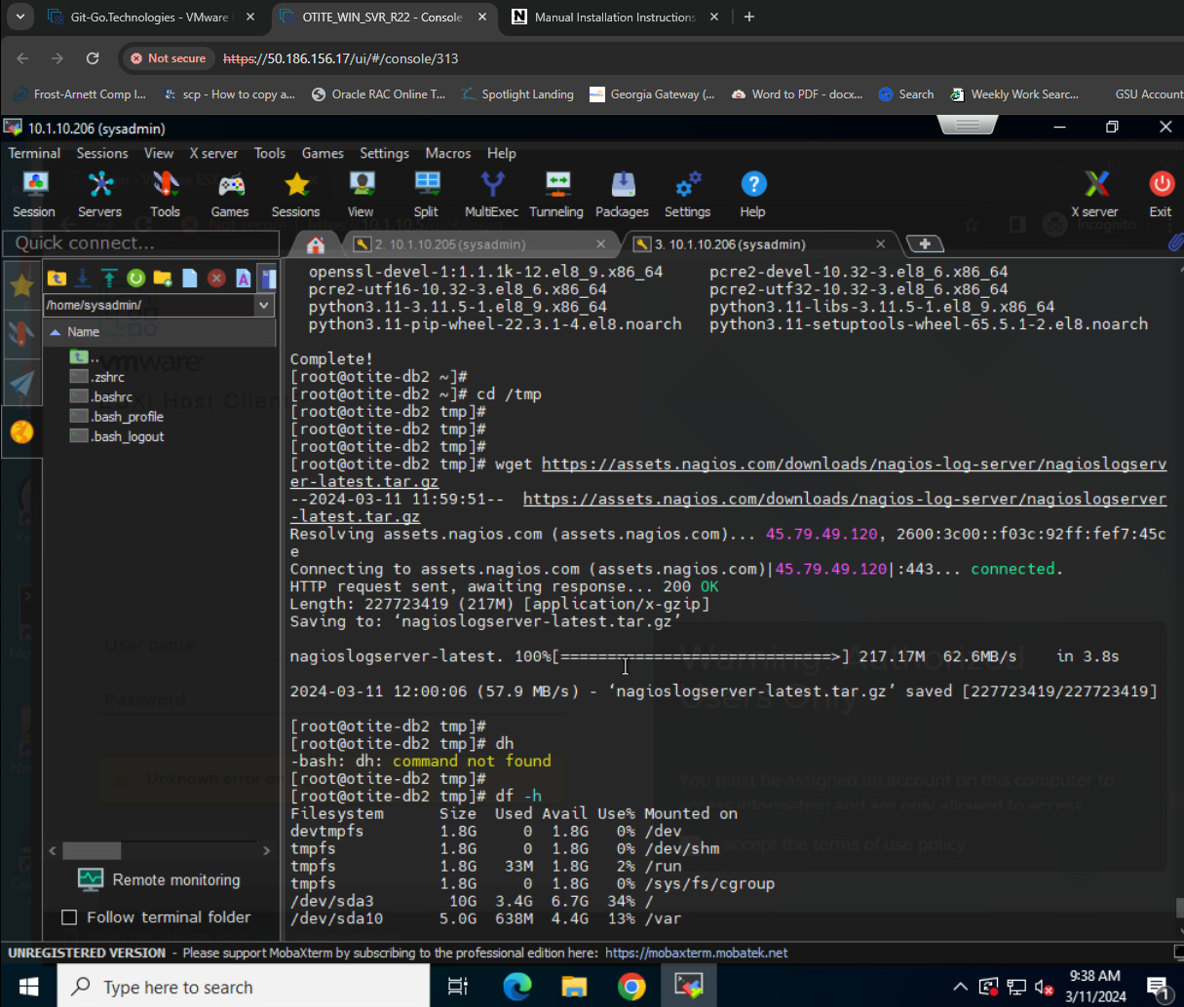
3. Use wget to access vendor package from site link
4. Verify the zip file package came into the tmp directory:
5. 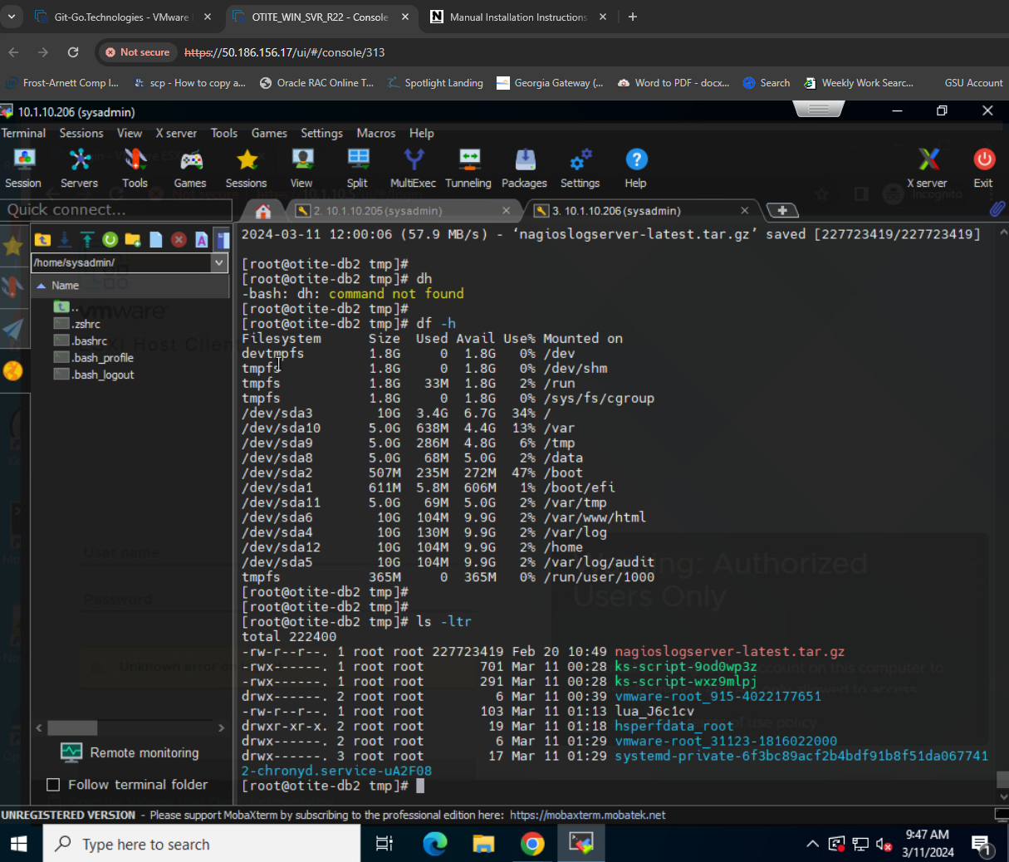
6. 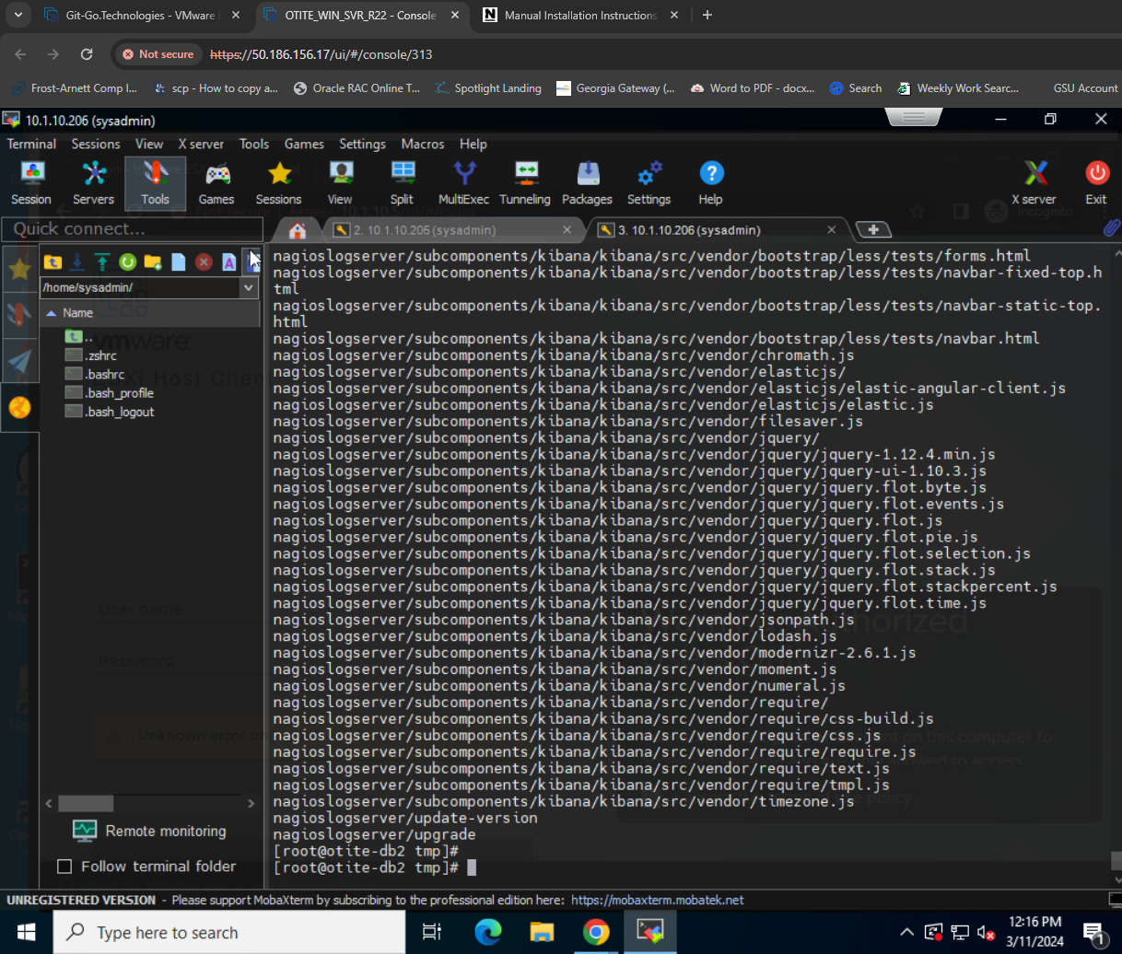
7. Cd into nagioslogserver:
8. 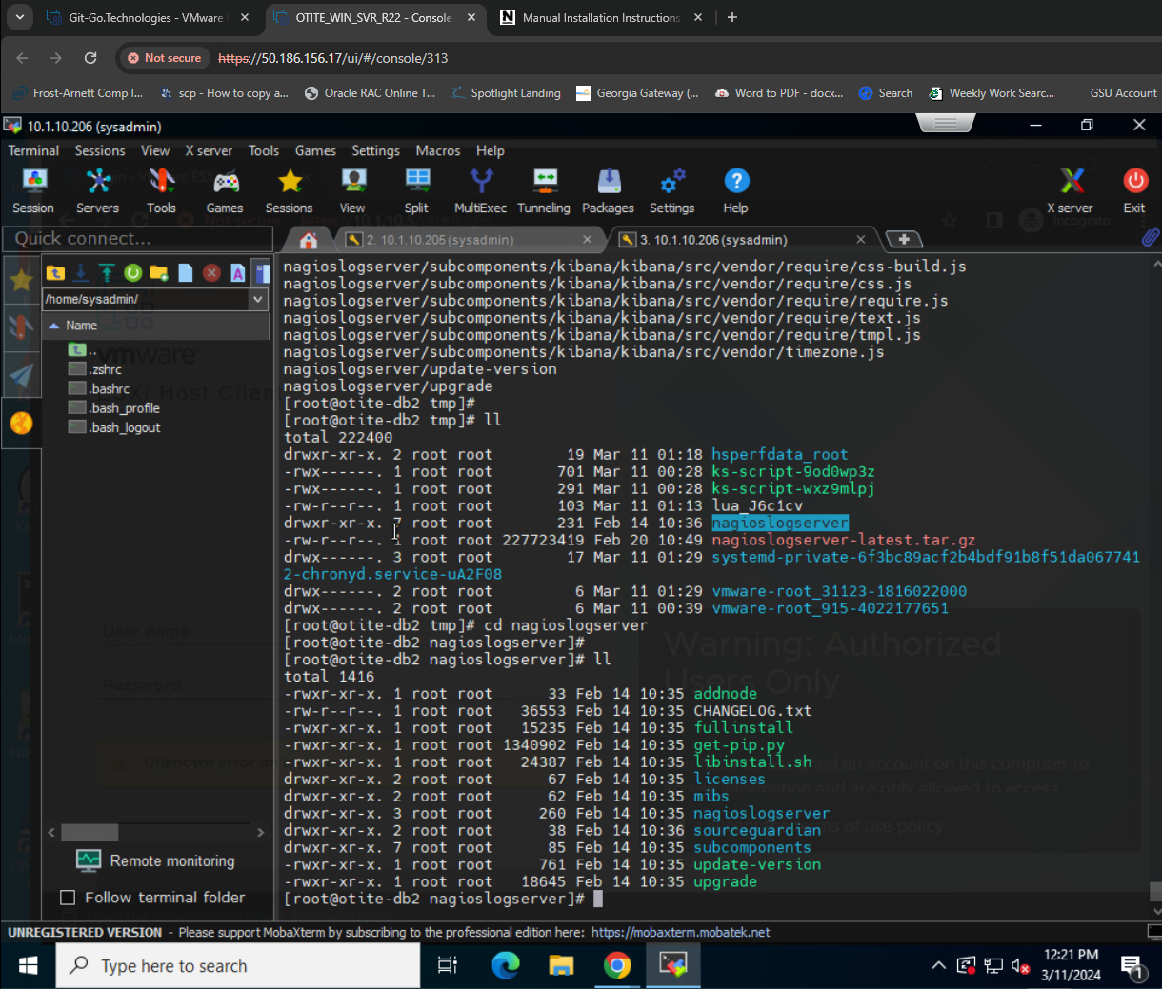
9. Make sure you update yum install and epel:
10. 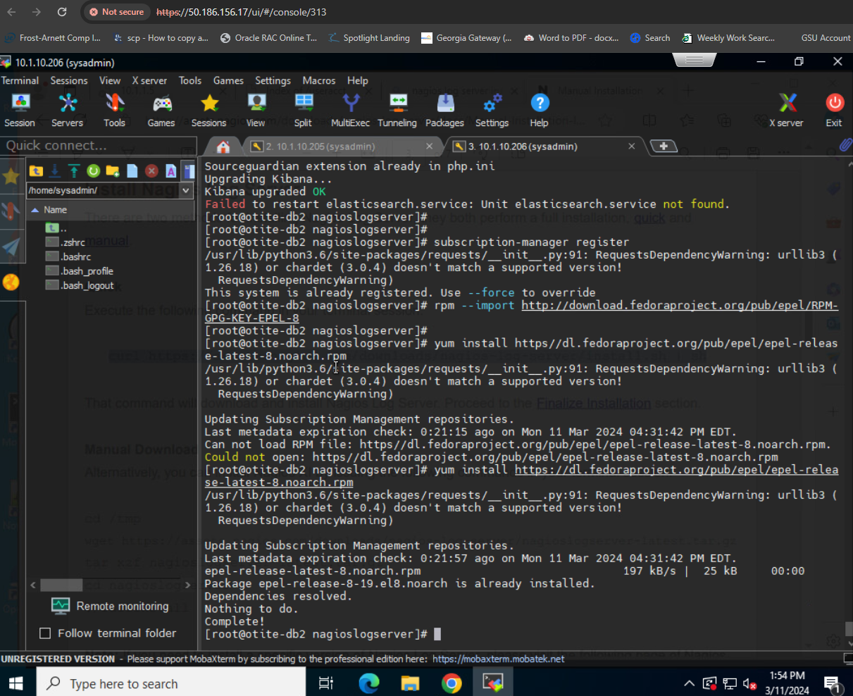
11. Check for the Apache service account, because we need it to be the owner of the Nagios application:
12. 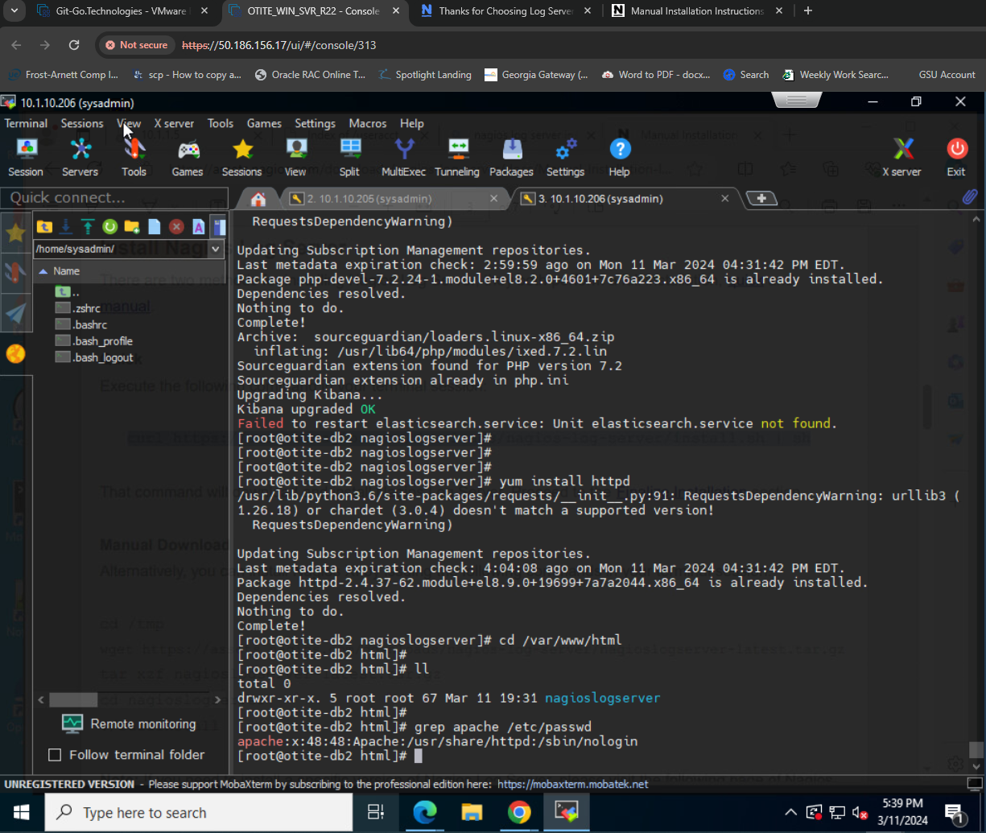
13. 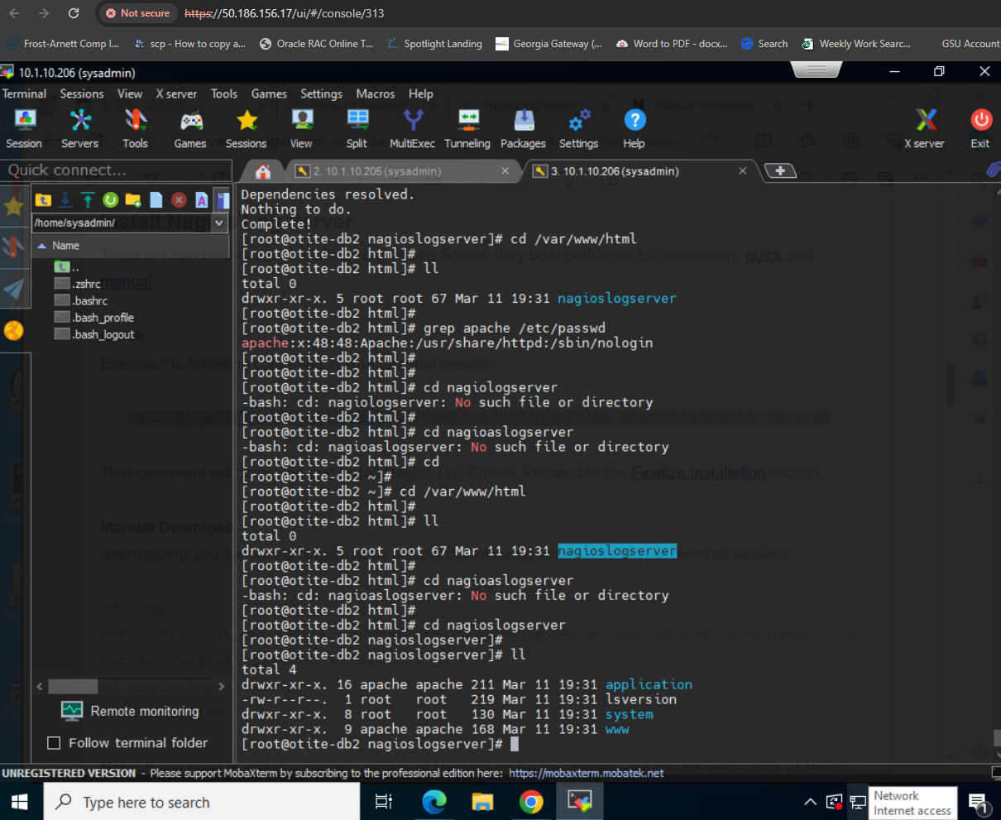
14. 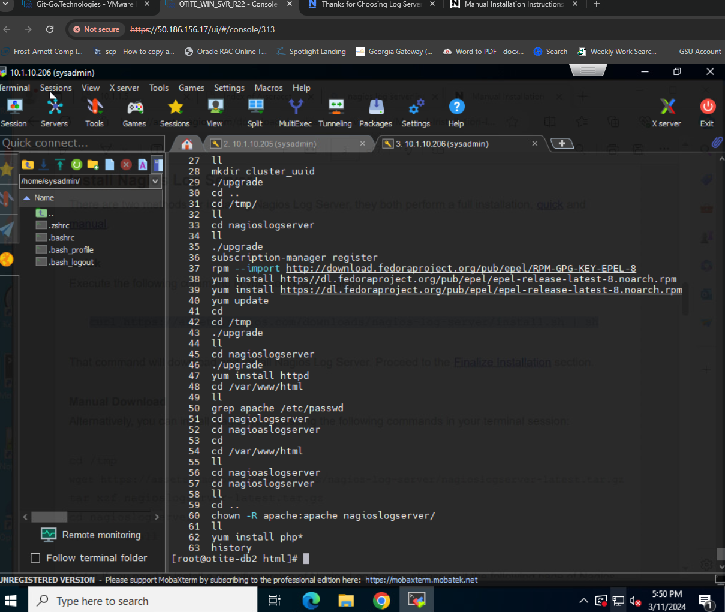
15. 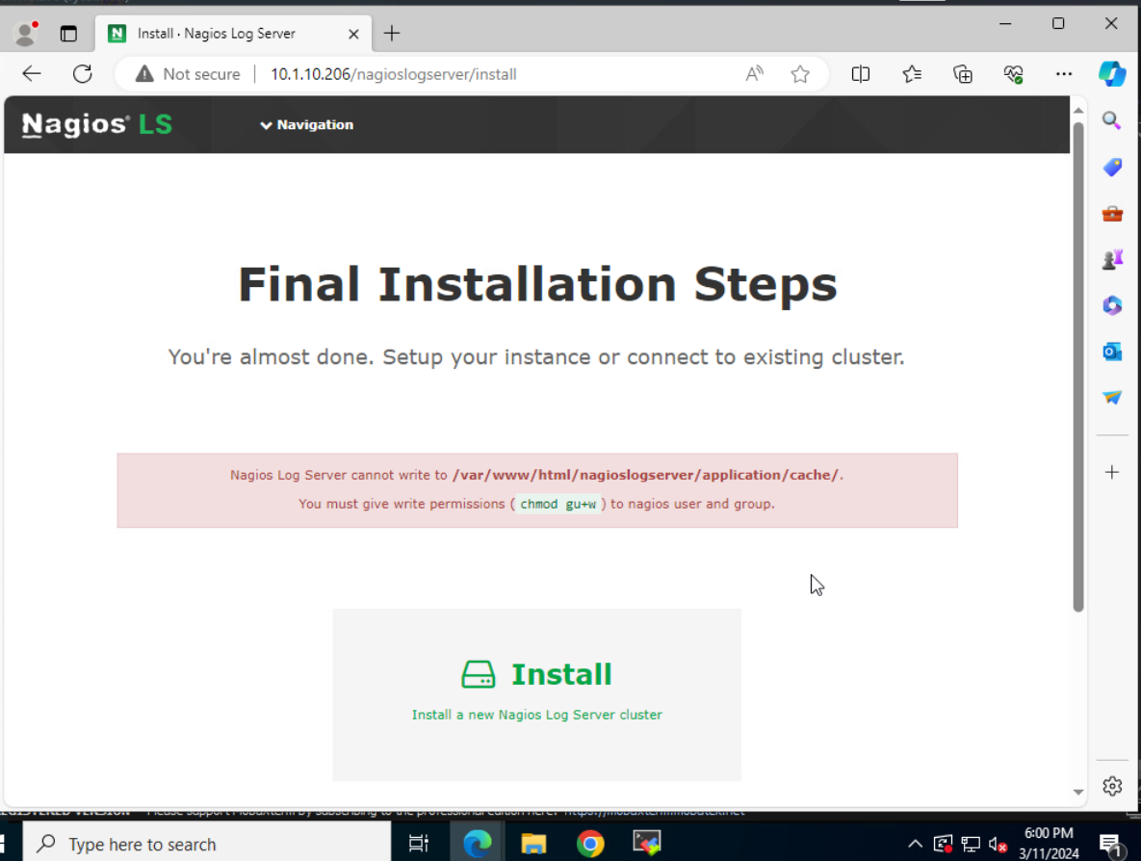
16. 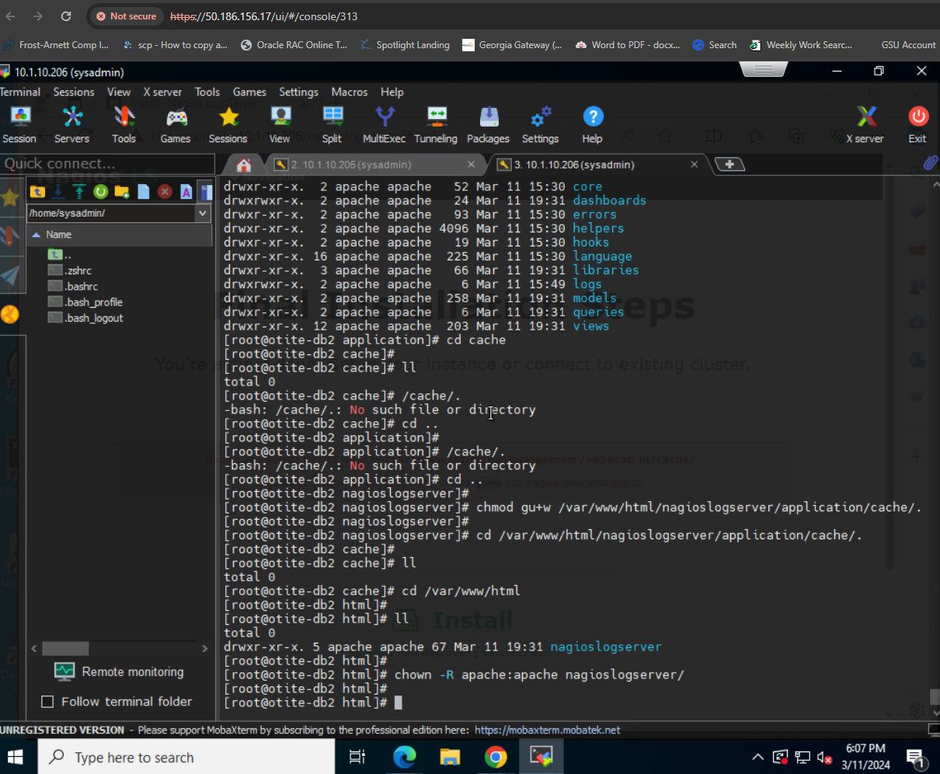
17. 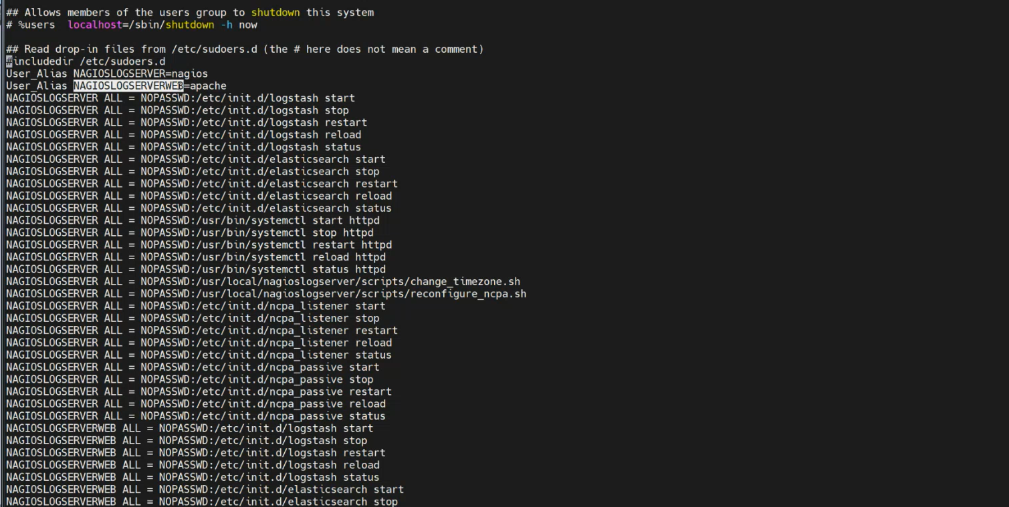
18. 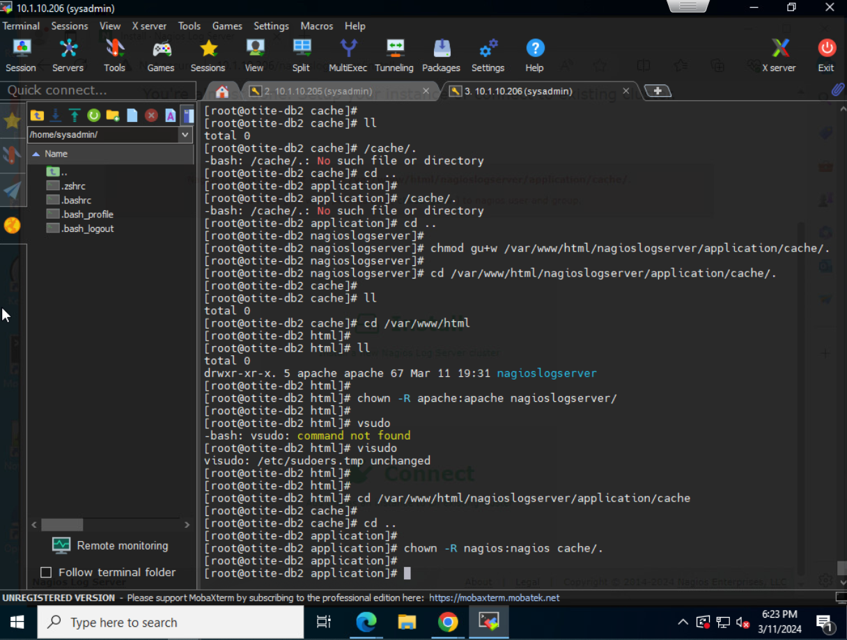
19. 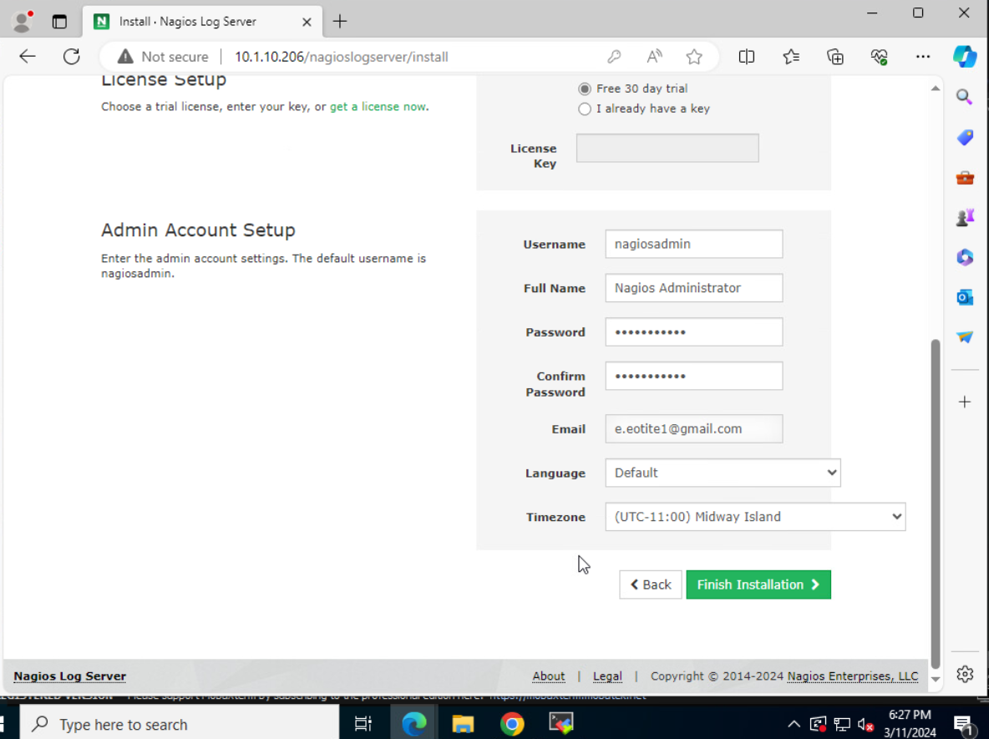
20. 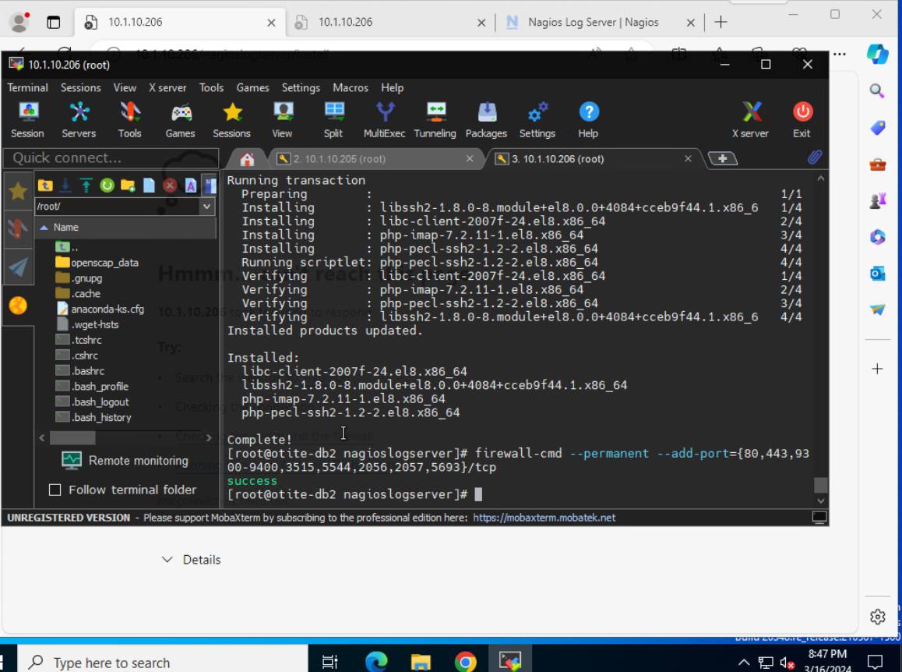
21. 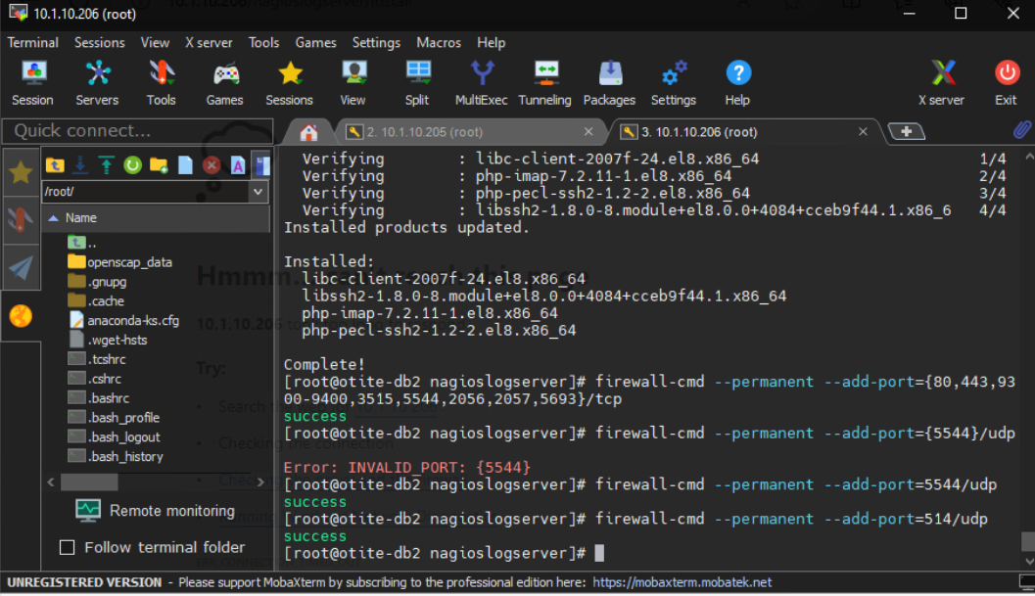

----But timed out by step #. 22----------------

1. 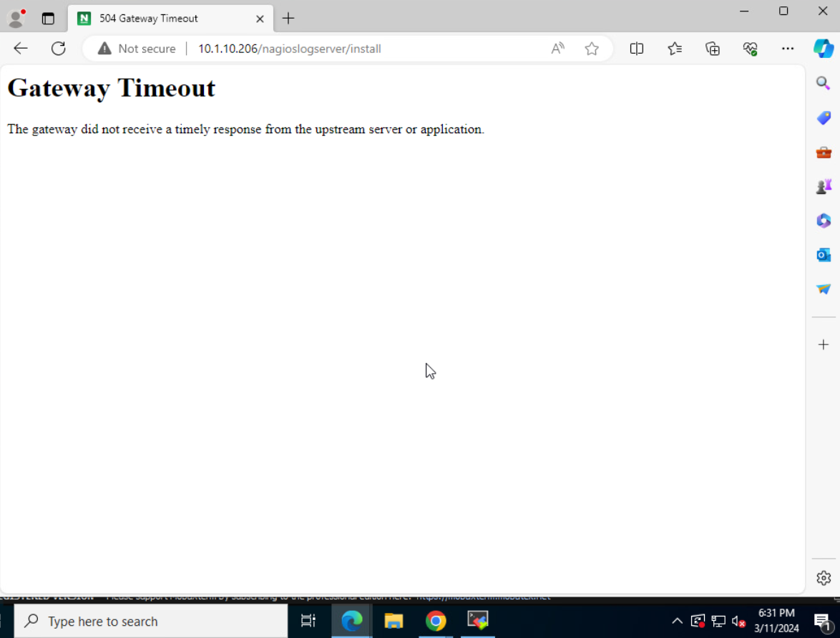
2. 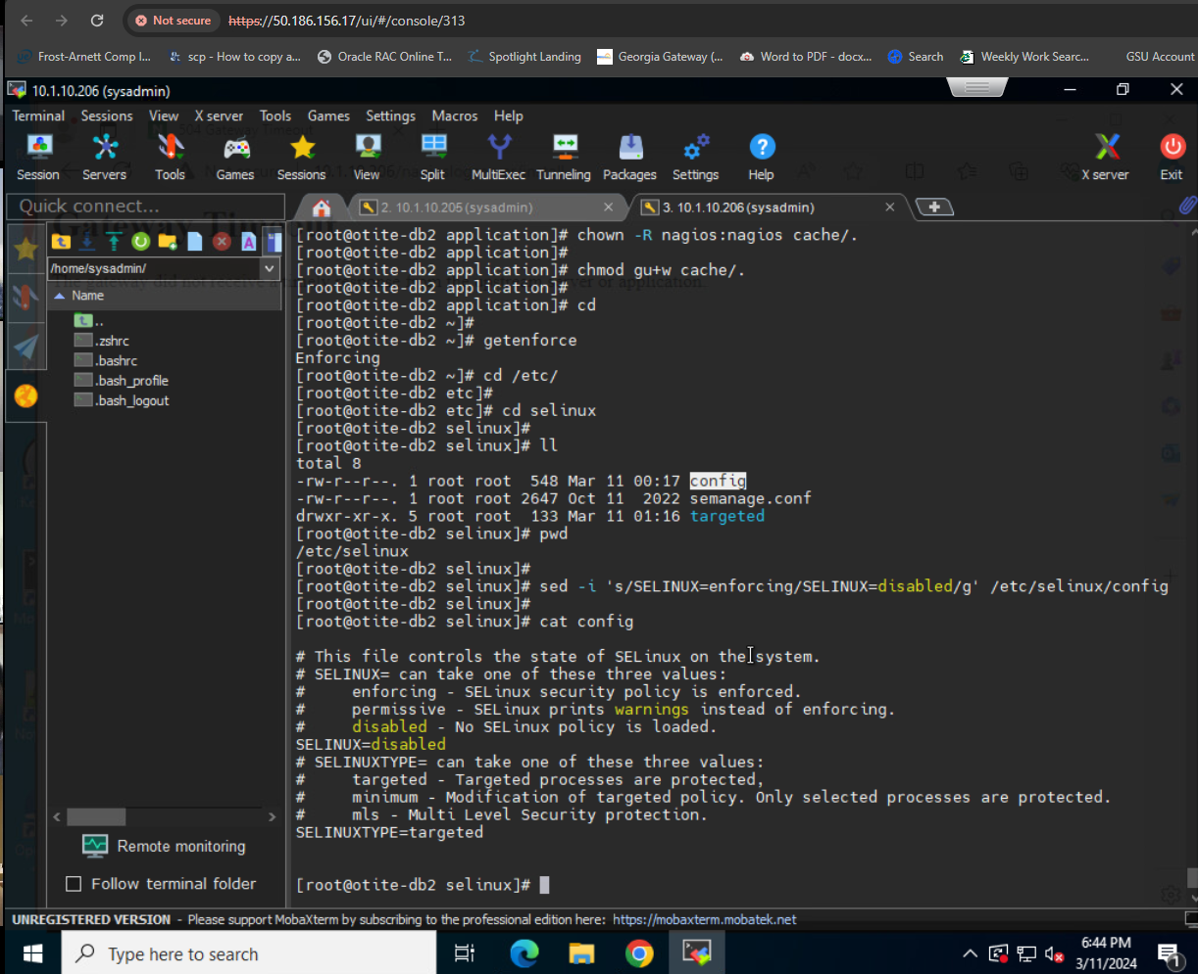
3. 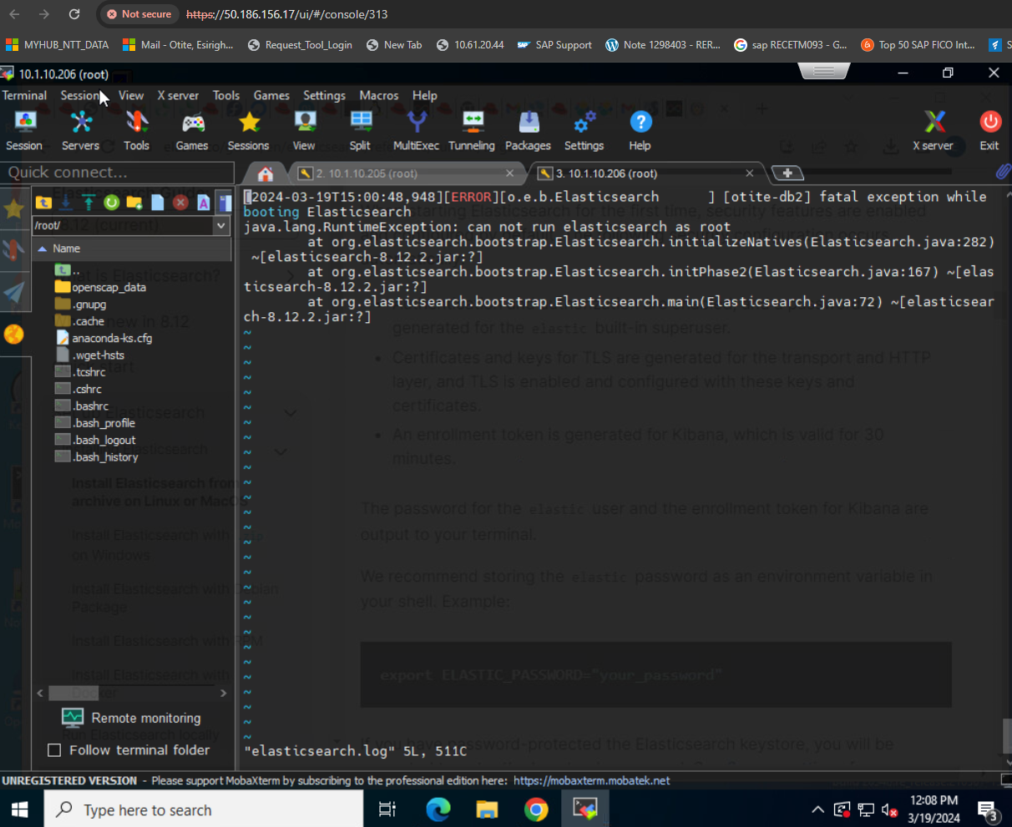
4. 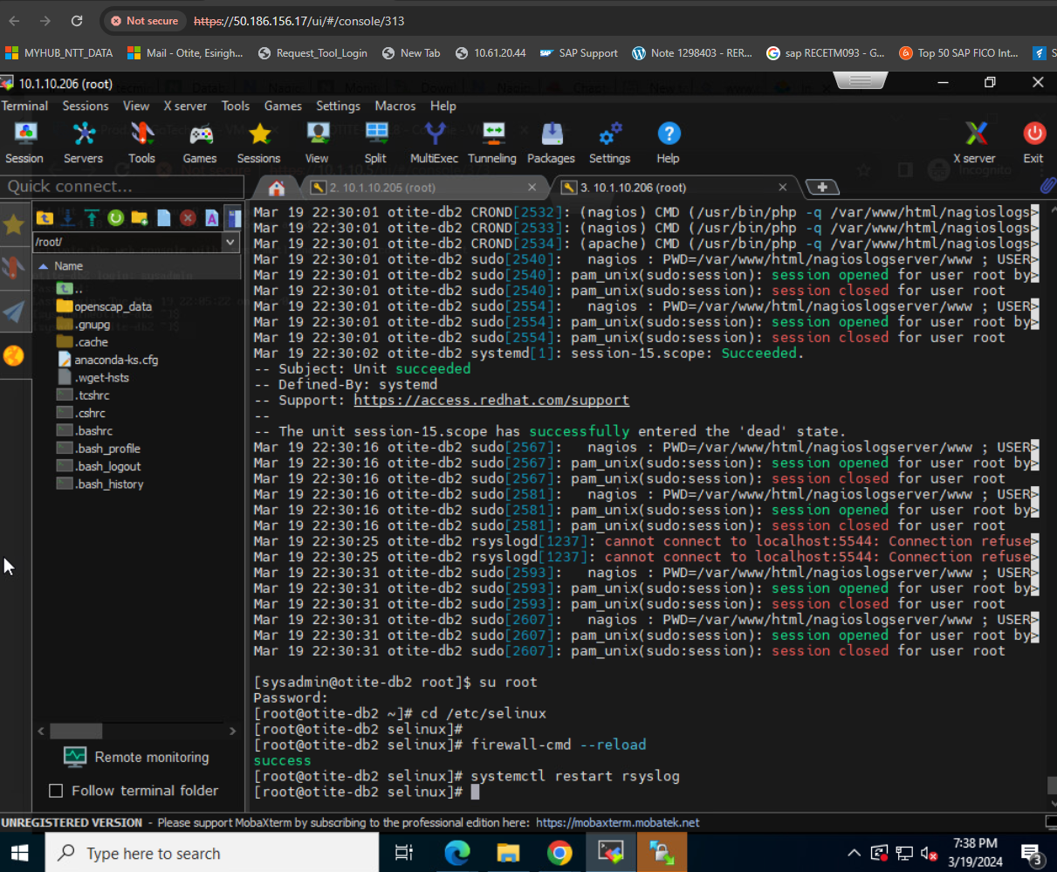
5. 